

# Year 10 Investigation 3

## Name: __________________________________________

Consecutive Numbers

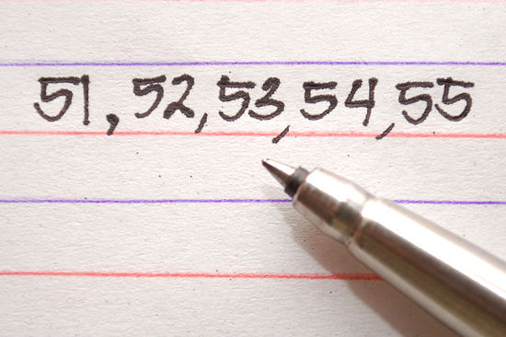

|  |  |
| --- | --- |
| Total (46) |  |
| % |  |
| Progress |  |

1. 6 can be written as the **sum** of 3 **consecutive** whole numbers (6=1+2+3).

(Consecutive numbers follow one after another. They are next to each other in order.) Show all the possible ways you can write the numbers 2 to 16 as sums of consecutive whole numbers? Note: This will not be possible for all numbers. (16 marks)

2:

3:

4:

5:

6:

7:

8:

9: 4+5, 2+3+4

10:

11:

12:

13:

14:

15:

16:

1. Which of these numbers could not be written as the sum of consecutive whole numbers? (2 marks)

What sequence do these numbers represent?

1. Pick any 6 **pairs** of consecutive whole numbers and make a list of their sums: (4 marks)

Numbers Sum

1.

2.

3.

4.

5.

6.

1. What do the sums have in common?
2. Using n and n+1 as your pair, prove your discovery in a) using algebra, given that 2n+1 must be an odd number.
3. Pick any 6 sets of **3** consecutive whole numbers and make a list of their sums: (7 marks)

Numbers Sum

1.

2.

3.

4.

5.

6.

1. What do the sums have in common?
2. What is the connection between the middle number and the sum?
3. How could you calculate 107+108+109 without adding the numbers?
4. If your 3 numbers are n, n+1 and n+2 then prove your discovery in a) using algebra
5. Pick any 6 sets of 4 consecutive numbers and list their sums and half their sums: (7 marks)

Numbers Sum Sum/2

1. 4 + 5 + 6 + 7 22 11

2.

3.

4.

5.

6.

1. If you write the numbers as (*n* −1) + *n* + (*n* +1) + (*n* + 2), then what can you say about the numbers that can be written as the sum of 4 consecutive whole numbers, from the result of combining then factorising this expression?
2. What do you notice about the middle 2 numbers?
3. Pick any 6 sets of 5 consecutive whole numbers and list their sums: (6 marks)

Numbers Sum

1.

2.

3.

4.

5.

6.

1. What do the sums have in common?
2. What is the connection between the middle number and the sum?
3. How can you calculate 41+42+43+44+45 without adding the numbers?
4. If your 5 numbers are n, n+1, n+2, n+3 and n+4 then prove your discovery in a) using algebra
5. Starting with 3 + 4 ,

repeatedly add a consecutive *integer* to both ends. Repeat 5 times. (4 marks)

i.e. 3 + 4

2 + 3 + 4 + 5 (once)

Explain why the sums are always a multiple of 7.